FIELD
FROM THE

Zara - Nigeria

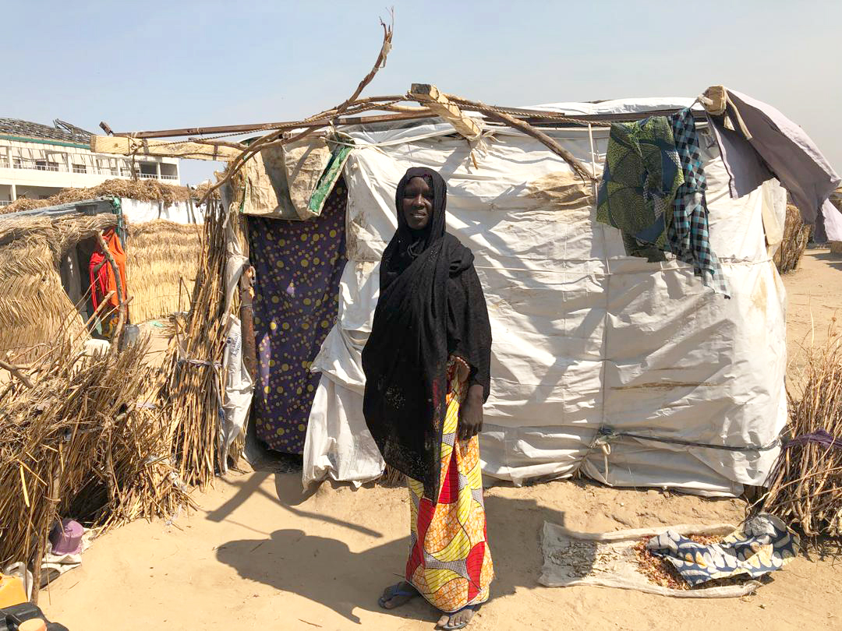
30-year-old Zara lives in a camp for internally displaced people with her husband and eight children in north-eastern Nigeria. Speaking to ACTED, ShelterBox’s implementing partner working in Nigeria, Zara said she used to be a farmer living off the land to provide for her family. After a flurry of attacks on their village, Zara and her husband decided to leave their home behind to find safety for their family. Together, they all took the journey to the camp by foot. Zara explained how much of a difficult decision it was to make the journey together with her children, signifying the urgency of that lifesaving choice:
“The thought of leaving everything we have in the village and leaving our relatives behind, and the fear of not knowing if I can reach a safe place without being hurt or kidnapped or even killed. The children were saying ‘mummy, are we leaving our belongings behind?’ and I told them to save our lives first.”
After trekking for three days and two nights, the family finally reached the camp, but having left all their belongings behind the family had nowhere to stay. In the beginning they were forced to sleep outside without shelter “under the sun and in the rain”, said Zara, with no protection from exposure to the elements and other threats posed by sleeping in the open.
The emergency shelter kit provided by ShelterBox and ACTED, which includes tarpaulin, timber poles, rope, nails, and various tools required for construction, has provided a safe shelter for Zara and her family.
When asked about the impact their new shelter has had for the young family, Zara said that it has made life much easier. She says that the shelter has provided a place for the family to keep their belongings, protection from the weather in the hot dry season, and cover from the strong rains in the wet season. “It has made my life so much easier.”
WWW.SHELTERBOX.ORG

