FROM THE
Sulawesi, Indonesia
FIELD
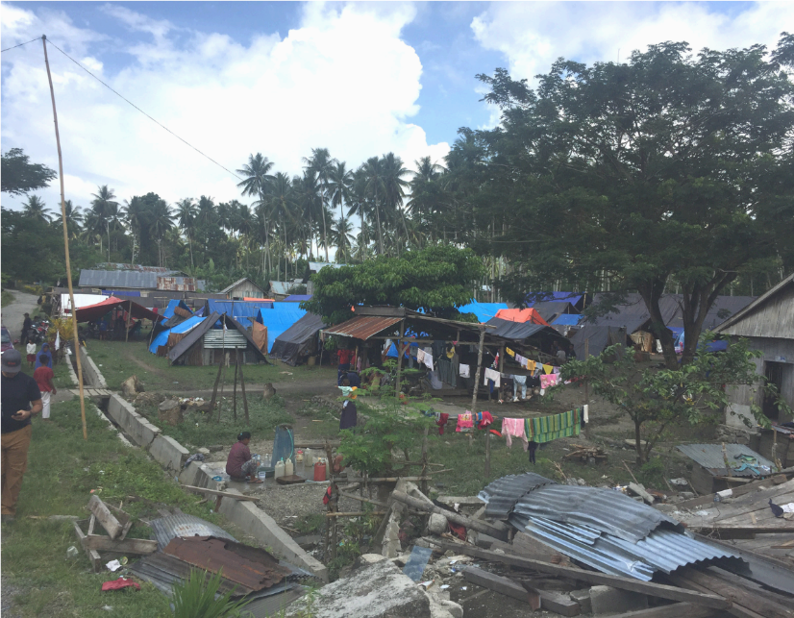
s

When the earthquake struck Central Sulawesi, Indonesia on September 28th, 2018 it destroyed the home of Fatnizar and her family in Tondo Village, Sirenja, Donggala. Many of the homes in her neighbourhood survived the earthquake, only to be swept away moments later by the subsequent tsunami. Fatnizar relocated with her husband and four children to a football field a little over 3 miles away.
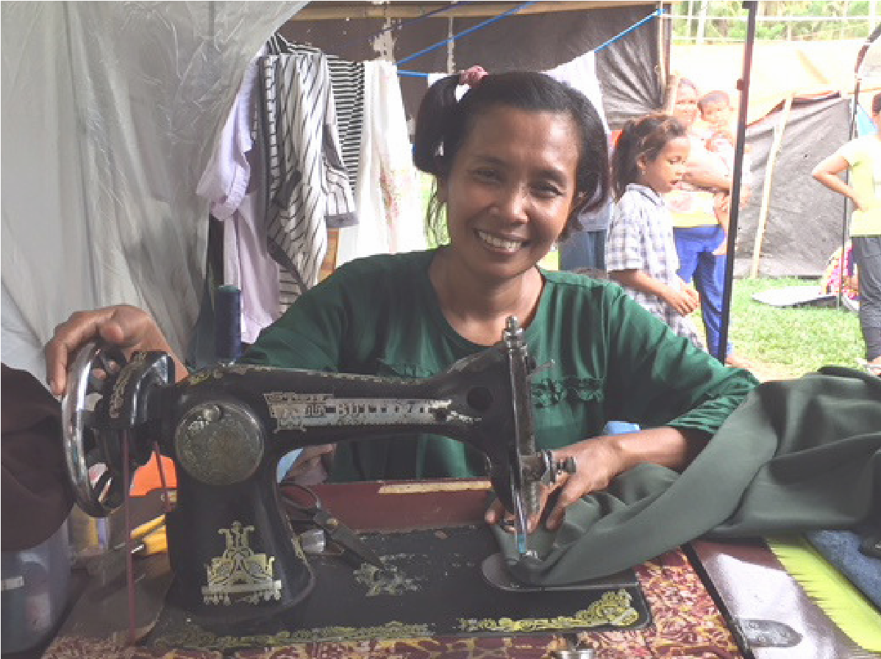
A total of 121 families took refuge on this field across from a school. Fatnizar’s family had to share a space under a large tarpaulin with fifteen other families. One month had already passed when ShelterBox first discovered this newly formed community. The village leaders identifies additional families in the area; and, with help from the local disaster organization and our local Rotary partners, we were able to assist 150 families with tents, mosquito nets, water filters and carriers.
When we returned the next week on a hot day with a light rain falling, Fatnizar was sewing under the awning of her tent. We learned that she had previously worked as a seamstress from her home, creating custom clothing for special orders. When the earthquake took her dwelling it also closed her two-year old business.
The tent not only provided a more private and secure space for Fatnizar and her family but also the opportunity for her to get back to work.

WWW.SHELTERBOX.ORG

